- Customer in Claims Vertical
• Italy
• Australia
• Germany
• Switzerland

- Applications / Services in Claims Vertical
Claimnet
• POI
• SPP (GCPP)
• Claim Task Routing
• Claims tracker
• FNOL

- Different levels of support in Incident Management process.
There are 3 levels -
•1st Level – Depending on the customer 1st Level support is done by either local IT or My-Allicia who is supporting 24/7 all over the globe.
The tasks of the 1st Level Support is to take primary tickets (a key/power user reports an incident and attaches the incident form), check if the incident form is filled in properly (all the ref-refences should be filled in, such as claim number where the error occurred, which user/users had been affected, which steps were taken, what exactly is the problem etc.) and then to route it to assignment group of User Support.
•2nd Level –It is settled in Vienna, Austria & Pune, India. The task of the 2nd Level User Support is to examine tickets that have been forwarded and to decide: the priority of the issue, to forward it with the right assignment group, to E-Mail the key user through SNOW in case there are some information missing, to try and reproduce the error, to get in touch with the 3rd level units and see if they have everything that is needed to fix the problem as soon as possible.
•3rd Level – The programmer units (Maintenance or DEVOPS) are a mixture of intern (Az Technology) and extern (SQS…) employees who work together on solving problems – if there are some missing information that are essential for the solution, they will contact 2nd level support and try to get that information from them, they will rewrite programs or make a bug- or hotfixes which will fix the problem and make it possible to work until the next version of the program is available or if that is not possible, they will share information on when and in which version this problem will be solved.
- Creation of a new SIM Snow ticket –
Open SIM Snow and log in with your credentials.
https://aztech.service-now.com/
To create a new ticket in SIM Snow choose the box-menu and click “Create New” in the “Incident” section.
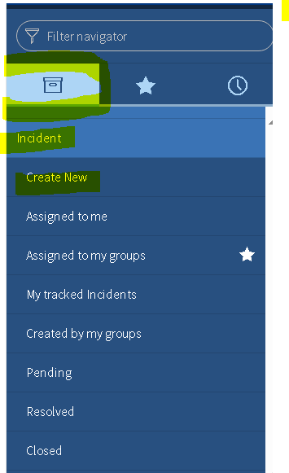

Filling in the incident mask
You will now see an empty Incident mask with an already created incident-number.
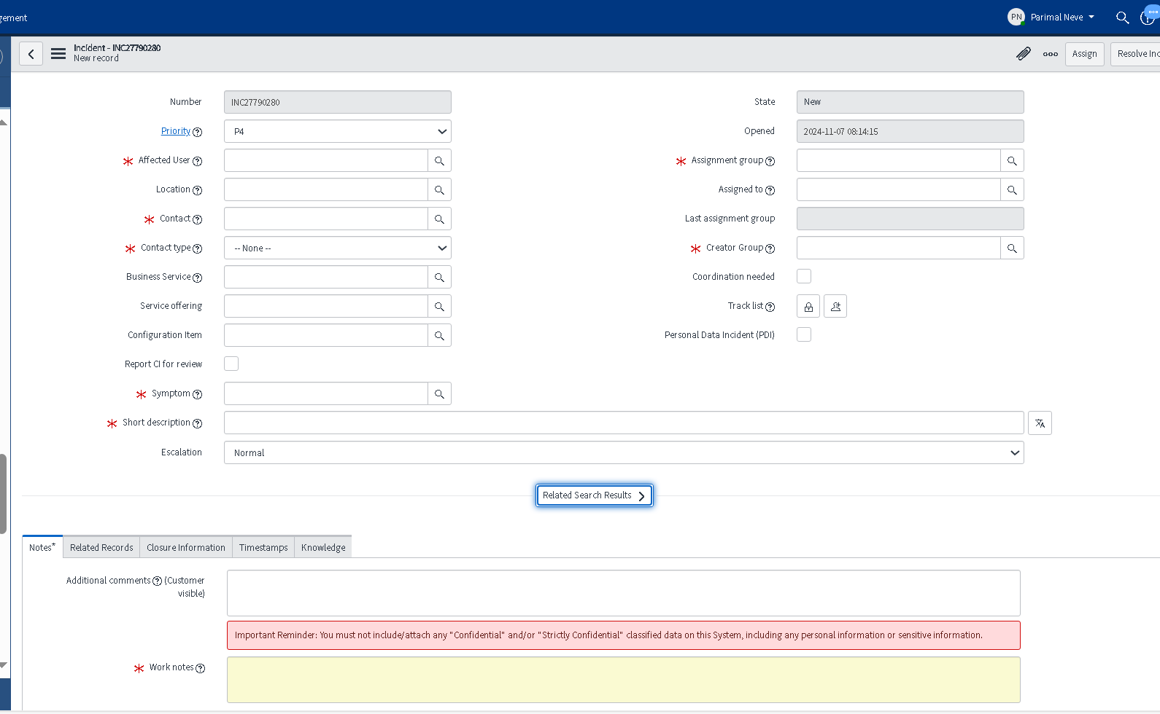

Now fill in the fields as shown below:
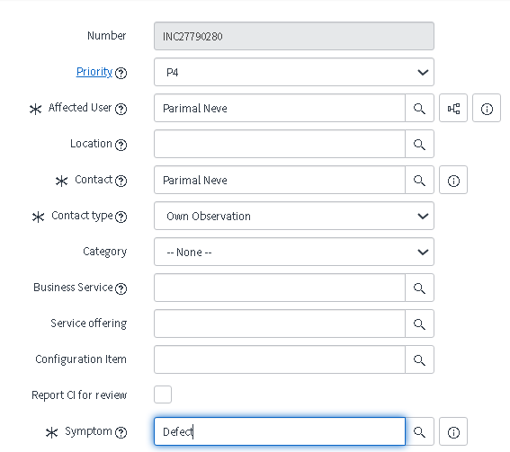
Affected User and Contact

Please note:
In SIM Snow the Affected User as well as the Contact should be your name.
For test tickets always enter yourself in both fields!

Contact Type and Symptom
Always choose contact type “Own Observation” and Symptom “Defect”.

Priority
Please note: In general, priotiy should remain P4, maximum P3 and must not be raised any higher as escalation over service desk is automatically triggered otherwise.

Short description and Worknotes
The short description is one liner description for the issue and resembles the issues “title”.
Work notes will be the “Problem Description”. Please enter your description and notes here.

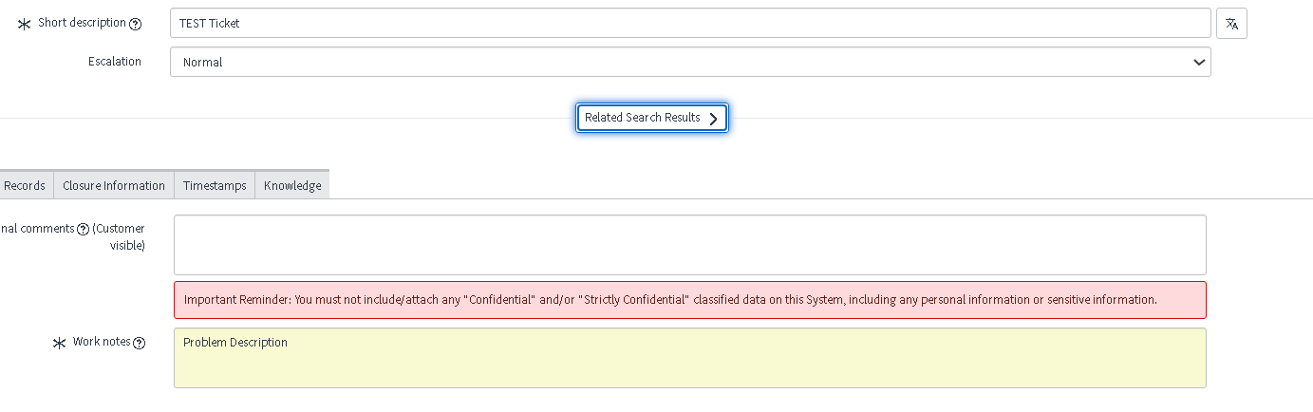
Attachments

To attach documents click the little”attachment” icon shown in the menu bar on top of the incident mask.
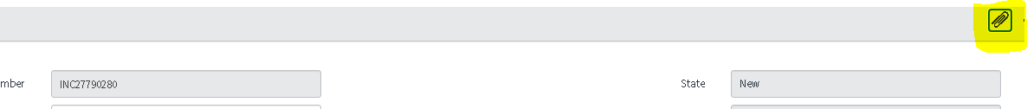
Click the “Choose file” button…
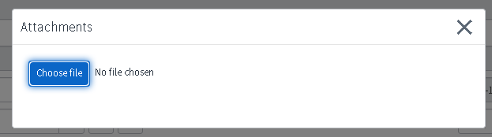
… and choose the file you want to attach from your desktop and attach it as usual.

The file is now attached and shown in the attachment pop up window. If you want to remove a file simply check the box next to the file and click “Remove”. In order to leave the attachment menu simply click the “X” on the upper right corner.
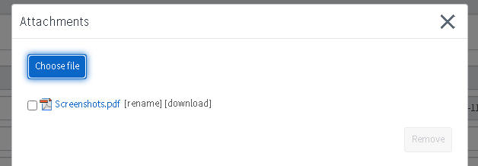

Assignment group and Creator group
The creator group will always remain according to the issue (Applicational / Service F-Groups).
If the above-mentioned steps have been done, click the “Assign” Button in the top menu bar. Incident will be assign to respective assignment group.
- What actions you will take if Service Now is not working.

For SIM SNow performance issue like tool slowness, morning shift MOD from Indian side should raise a ticket in SIM SNow using Functional group “A.TEC.GLOB.ITSM.SERVICENOW” and drop an important email to everyone. MOD AT should be informed via handover email. In case if performance is too low and we are not able to create a ticket in SIM SNOW, then kindly try accessing SIM service Now in Indian VD and inform AT side via email.
*NOTE – In both scenarios please have a closer watch on Incident Management related notification emails.

- State of Service Now Ticket –

- New
- Assigned
- Work In Progress
- Customer Info Required
- Resolved
- Closed

- Incident Management
The process of managing unexpected disruptions or reductions in service quality. The goal is to restore normal service operation as quickly as possible.

- Work Notes -
Work notes will be the “Problem Description”. Which contains all the information (Including Minimum Information to be provided ) which is required to analysed the issue.

- Additional Comments -
Additional comments will be sent to user through an automatic email via Service Now. Through additional comments you can ask user required information and confirmation on provide solution.

- Child Incident Process
When we receive multiple incident for same or existing one issue and both are reported on same/ certain time period like within 4-5 hours / same business day then we , first reported issue is keep as PARENT INCIDENT And other incident reported later we will link to PARENT INCIDENT as CHILD INCIDENT.
In of IT service management and specifically within ServiceNow, a "child incident" refers to an incident that is linked to another incident, known as the "parent incident." This relationship is used to manage and organize related incidents effectively.
- Steps For Linking Child INC to Parent INC
Please follow the below steps for linking an incident to the Parent incident in case of duplicate issues-
• Go on Child incident -> Navigate Related Records->
• Enter Parent incident number in the Parent Incident Field
• Add Proper work Note / Information in Work note Field notes in Child INC
• Remove yourself from assigned to and save
The incident will be linked to the parent incident as child incident.
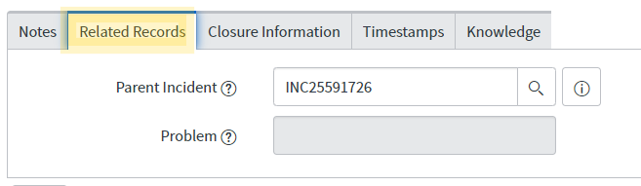

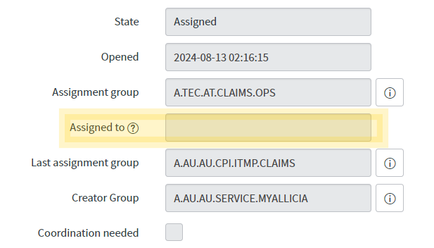

After Creating Child INC We can See a Notification on top of page of Child Incident
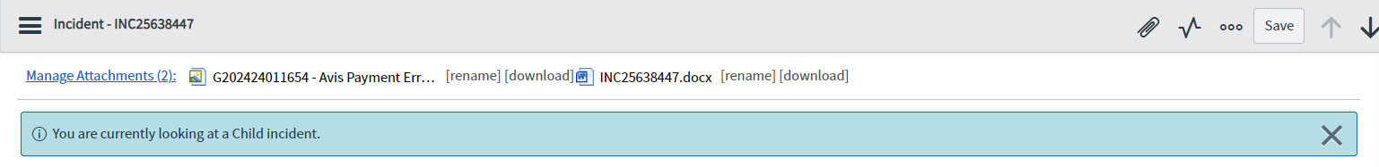

- Incident Management For AUS

End User Report to 1st LV /Local IT
Arrived in 2nd lv. Claim Ops
Ticket reported and comes to 1st LV /Local IT
Information are missing – Put in Cust Info
all information there - assigning to 3rd Lv
3rd Lv. needs more information back to 2nd LV
ask the customer for the information -– Put in Cust Info
Ticket will be sent again to 3rd lv for a solution -once a solution - same steps as mentioned
3rd Lv. find a solution and assign it to 2nd Lv
ask the user for –Put in Cust Info

